Q1 OUTPUT:-
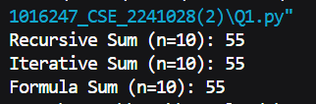
Q2 OUTPUT:-
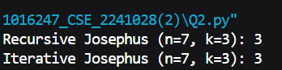
Q3 OUTPUT:-
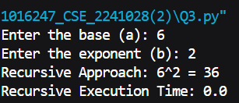
Phantom tracking output:-
